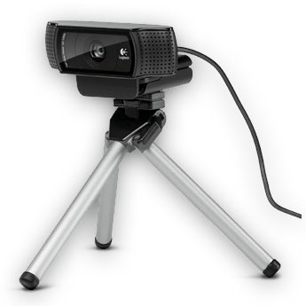
Logitech HD Pro Webcam C922
DEscription
This high quality webcam has a 1080 p HD sensor. It records at 30 or 60 frames per second and its features include digital zoom, manual and automatic focus & exposure plus technology to help keep your video bright and colourful. Unlike other webcams it provides MJPEG encoded video which can be recorded by Dartfish Software.
PROS
Good video quality (up to 1080 p)
USB 2.0 connection so no need for additional power
Attaches to any tripod
Two webcams can be easily used to benefit from dual camera input in InTheAction
CONS
Lacks the features of a camcorder e.g. limited digital zoom only
INSTALLATION
Simply connect your webcam to a USB port and Windows will automatically install the necessary driver.
IMPORTANT It is not necessary to install any Logitech drivers or software to use the C922. We recommend that you don’t.

Optimal camera settings
When the camera is selected, various settings buttons appear:
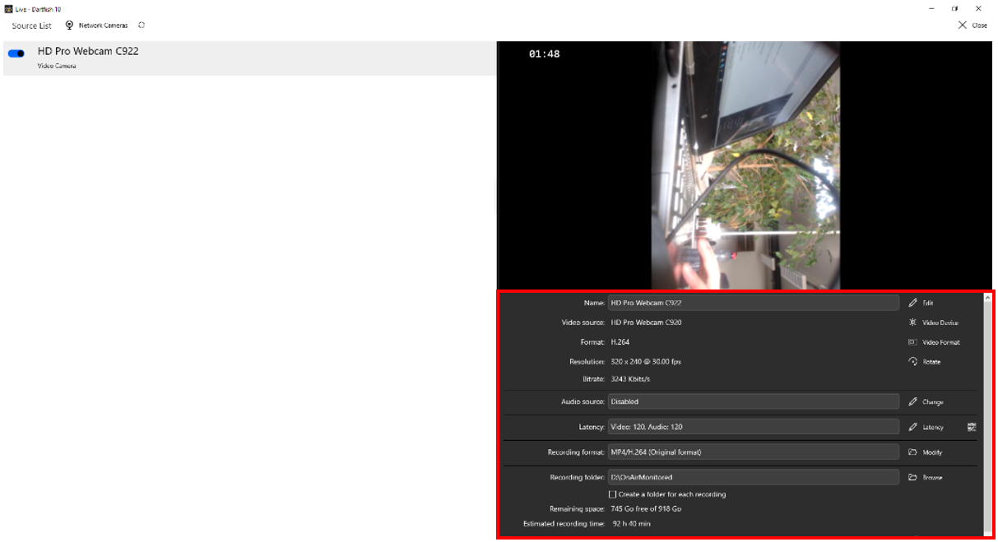
Click the configure format button to configure these recommended video settings:
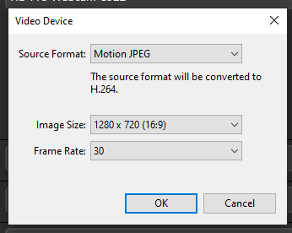
Frame Rate: 30.000
Color Space / Compression: MJPG
Output Size: 1920 x 1080
Or
Frame Rate: 60.000
Color Space / Compression: MJPG
Output Size: 1280 x 720

USEFUL TIPS
If recording from two webcams, connect each to a different USB port on your computer – do not use a USB hub
If using USB extension cables, we recommend top quality active extension cables (e.g. www.lindy.com); these feature built-in electronics which regenerate the USB signal.
Click the Configure device button to configure the best image for video analysis
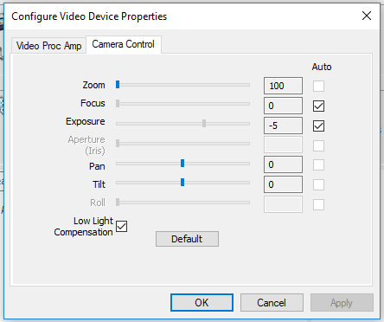 | Set Exposure to reduce motion blur.  Zoom and focus can also be configured here  To prevent flicker under artificial light, set the Powerline frequency to the AC frequency of the power supply for your country (e.g. US = 60 Hz, EU = 50Hz)  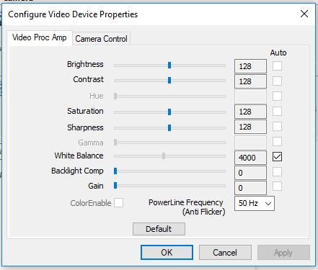
example of USE CASES
These are an inexpensive and easy solution for static uses like bike fitting or gait analysis.

